**3D CV: A Creative CV System Beyond A4 Paper**

**Leung Tsun Hei (17229421)**

**Installation Guide**

Step 1. Download Microsoft Visual Studio Code from <https://code.visualstudio.com/> and Install it

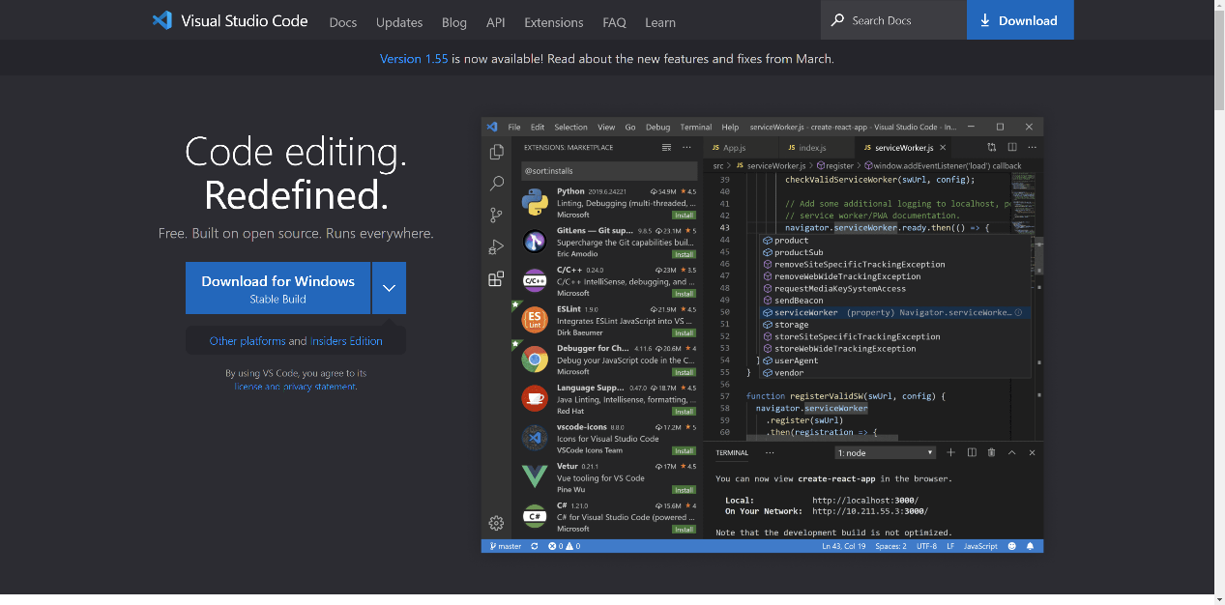

Step 2. Download Node.js from <https://code.visualstudio.com/> and Install It

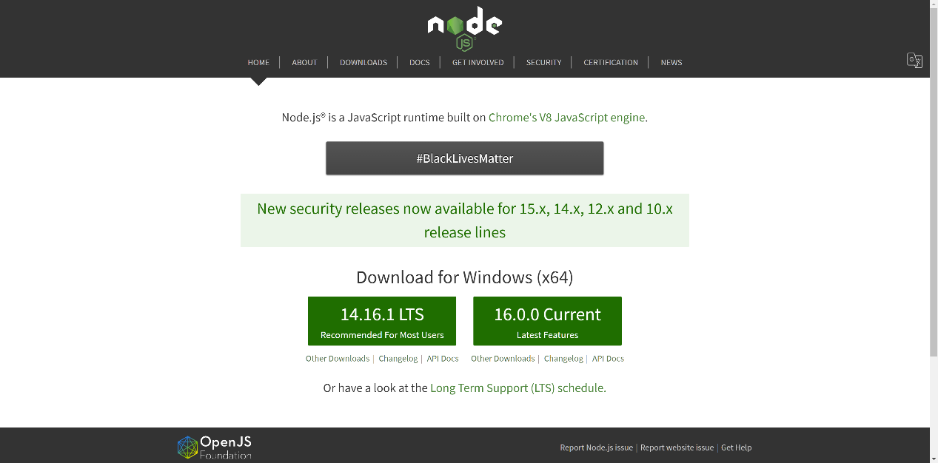

Step 3. Open Terminal and type command “npm install sails -g” to install Sails.js

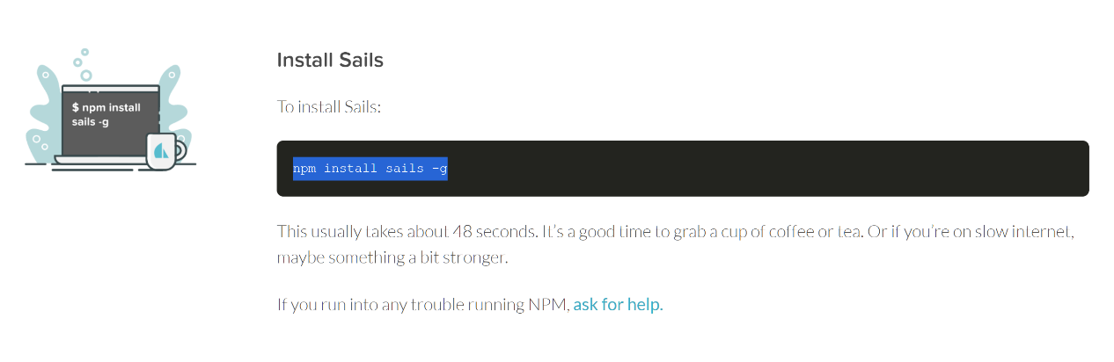

Step 4. Download the source code zip file, unzip it and open the folder with Visual Studio Code

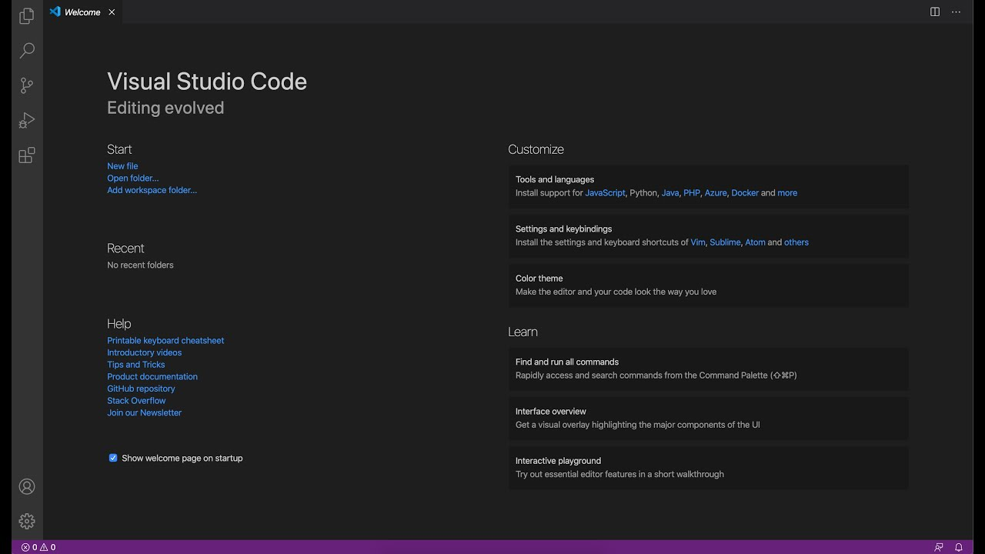

Step 5. Open Terminal and input command “npm install”

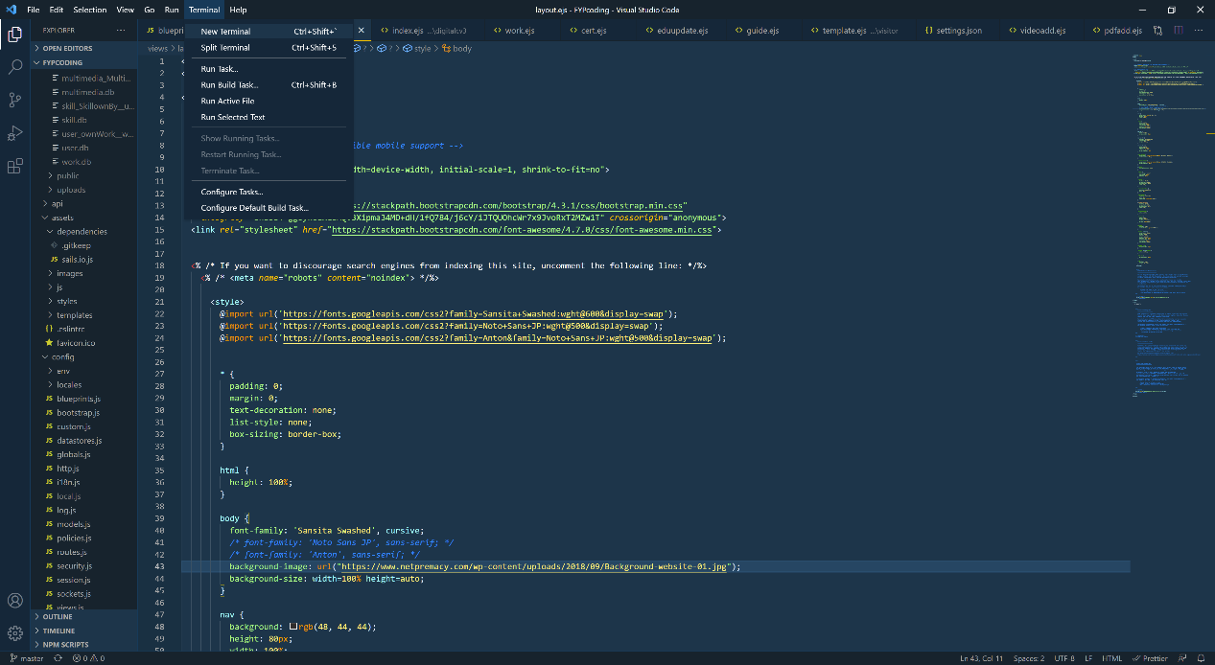

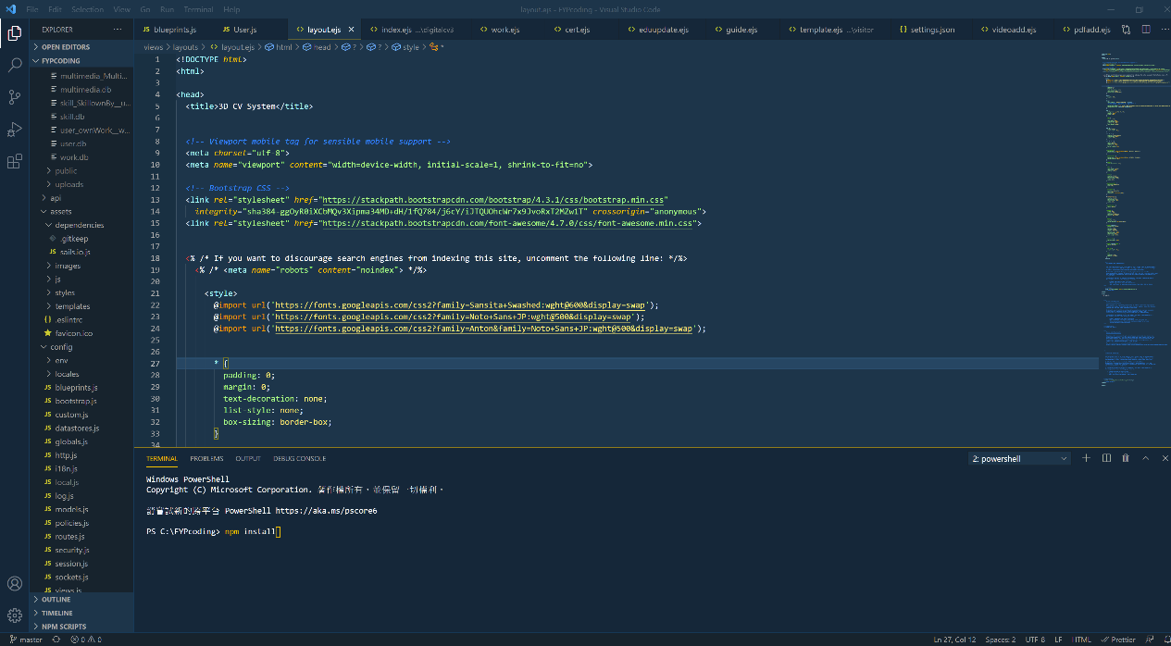

Step 6. Input command “sails lift” to run the system

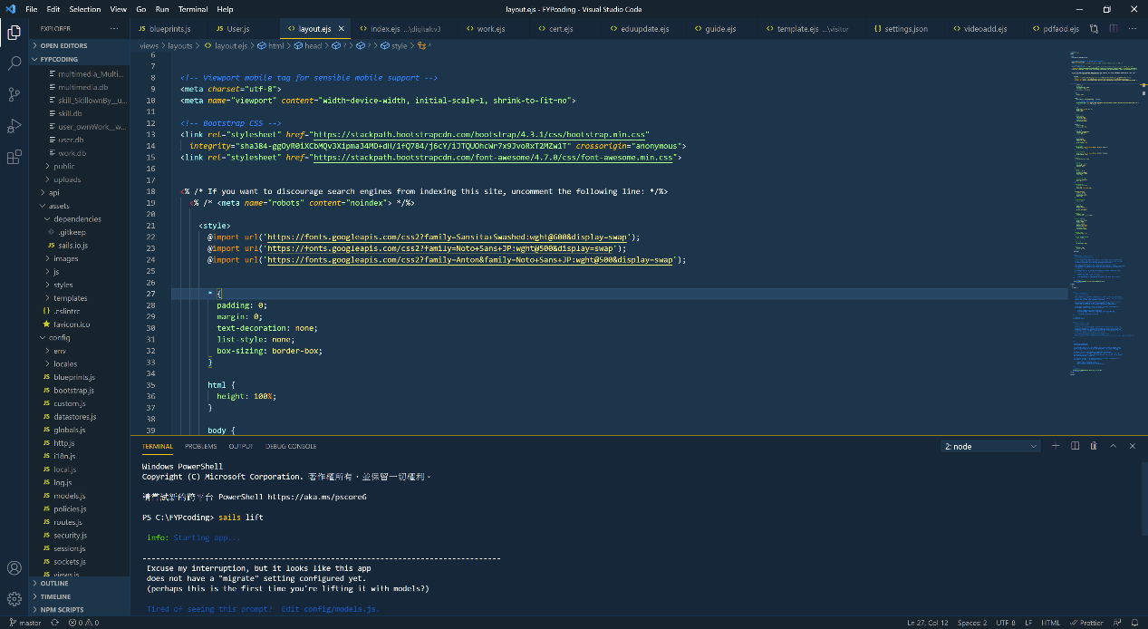

For not altering the current data: Input 1

For removing all the current data: Input 2

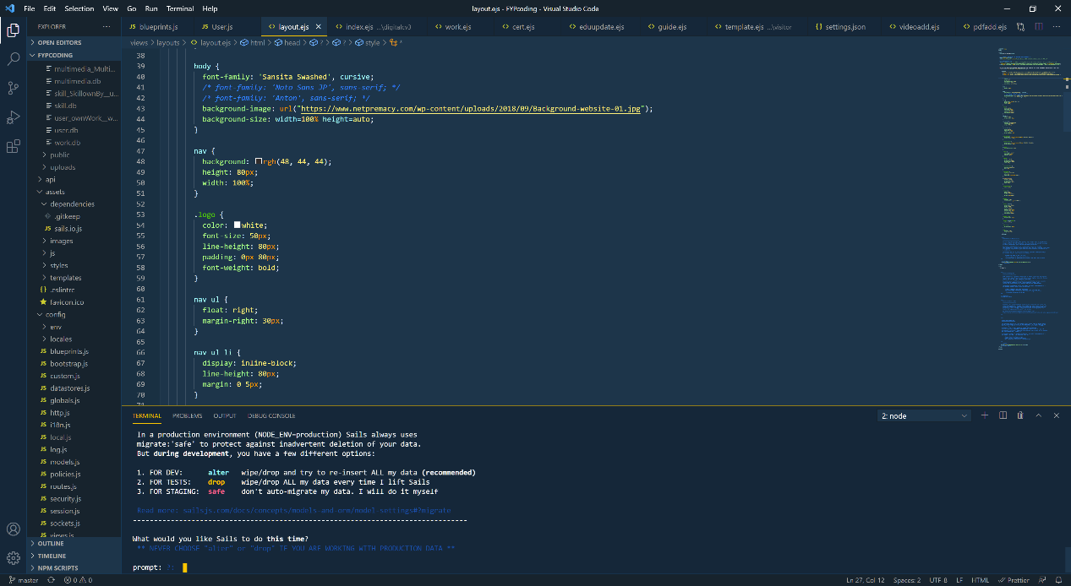

Step 7. Open browser and type the link <http://localhost:1337/>

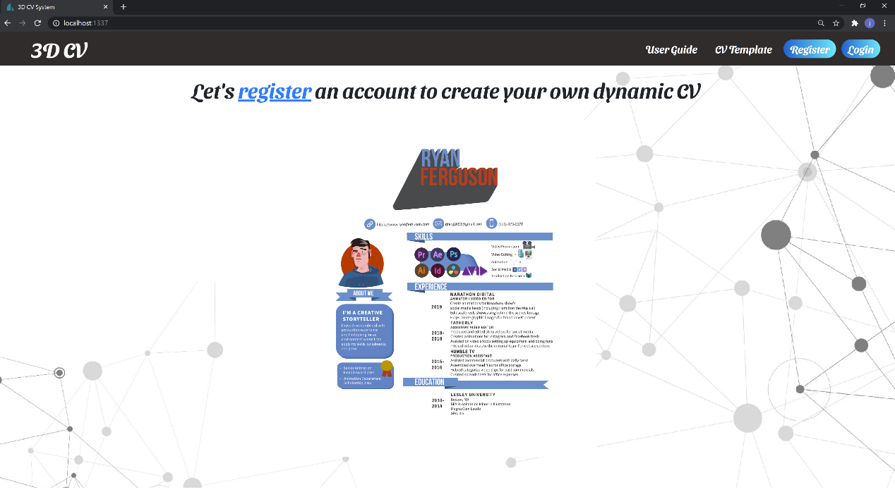

Initial User account:

Account: jay01 password: Password123

Account: jay02 password: Password123

Account: jay03 password: Password123

Account: jay04 password: Password123

Account: jay05 password: Password123

Account: jay06 password: Password123

Initial Admin account:

Account: admin01 password: Password123

Account: admin02 password: Password123